Keeping yourself clean and healthy

Health and Hygiene for Class 1 EVS
A person's emotional, physical, and mental well-being can be defined as health. It is necessary to maintain a healthy lifestyle which comprises inculcating healthy habits and keeping the surroundings clean.
This concept will explain the importance of health and hygiene.
After going through the concept, the learners will be able to:
- Understand the importance of cleanliness.
- Enlist healthy habits.
- Explain the meaning of good health.
Each concept is explained to class 1 students using descriptions, illustrations, and concept maps. After you go through a concept, assess your learning by solving the two printable worksheets given at the end of the page.
Download the worksheets and check your answers with the worksheet solutions for the concept Health and Hygiene in PDF format.

Why Should We Keep Ourselves Clean?
- If we do not keep our bodies clean and maintain good personal hygiene, we may suffer from many diseases.
- As a result, we won’t be able to go to school, play with our friends or do any other activity.
- So, we need to follow specific rules in order to stay healthy.
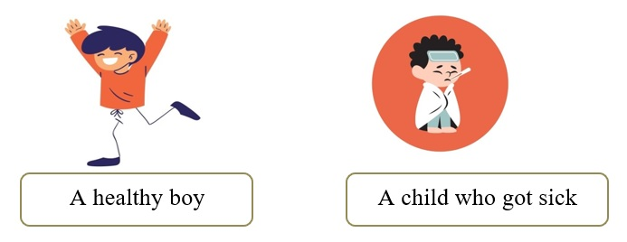

Why should we keep ourselves clean?

1.Brush Your Teeth Twice a Day:
- We should brush our teeth using a toothbrush and toothpaste to keep our mouths clean.
- Otherwise, our mouth will remain dirty, allowing germs to grow on our gums and teeth.
- These germs can cause cavities and infections.
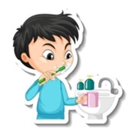

2. Comb Your Hair:
- We should comb our hair with a clean comb twice a day.
- Combing keeps our scalp and hair healthy.
- If we do not comb our hair, the dust in the air can make our hair dirty and tangled.
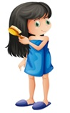

3.Bath Every Day:
- We should take a bath every day and clean ourselves with soap and water.
- A clean body keeps us healthy and away from diseases.
- After a shower, we should dry our bodies with a clean towel.
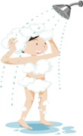

4.Wear Clean Clothes:
- We should always wear washed and clean clothes.
- Dirty clothes make us smell bad and can cause skin diseases.
- Our clothes should be washed every day with detergents and dried completely.
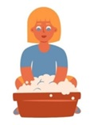

5. Trim Your Nails Short:
- We should trim our nails from time to time because long nails can trap dust, dirt, and germs.
- When we eat food with our hands, those germs get inside our bodies and make us sick.
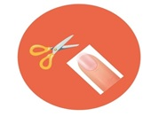

6.Wash Your Hands Properly Before and After Having Meals:
- Before and after meals, we should wash our hands properly with soap and water.
- It keeps our hands clean and germs-free.
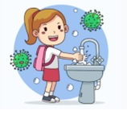

7.Rinse the Mouth After Every Meal:
- Rinsing our mouths with water after every meal keeps our gums and teeth healthy and protects us from bad breath.
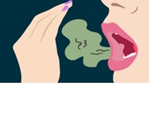

8.Wash Your Hands with Soap After Using the Toilet:
- We should always wash our hands with soap and water after using the toilet.
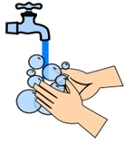

9.Flush the Toilet After Use:
- We should flush the toilet every time we use it.
- Not flushing the toilet can lead to many infections.
- We must remember that a toilet is used by many, so it is our duty to keep them clean.
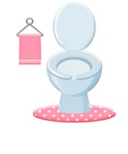

10. Always Use a Clean Handkerchief:
- One must cover up their mouth while coughing and sneezing with a clean handkerchief.
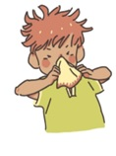

11.Use a Soft Cotton Bud to Clean Your Ears:
- A soft cotton bud should be used to keep your ears clean.
- Clean your ear wax every week, and do not poke your ears with sharp objects.
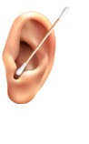

12.Never Poke Your Nose:
- Do not poke your nose with your fingers.
- Putting dirty fingers inside your nose can make you ill.
- Clean your nose while taking a bath.
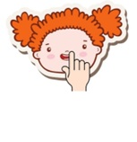

Maintaining Cleanliness at Home:
- It is an essential task for all to keep a clean house.
- A dirty house can make us sick as many germs can grow in such conditions.
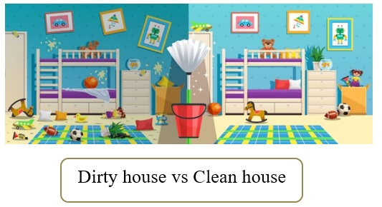

How to Keep Our House Clean?

a) Dusting:
- Dust and dirt from walls and ceilings should be cleaned.
- Always keep your bed clean and make your bed every morning.
- Leave your shoes in the shoe rack after reaching home from school or the playground.
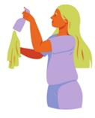

b) Clean the Floors Every Day:
- Clean the floors of the house with floor cleaners and water.
- It kills the germs present on the floor.
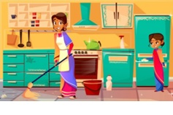

c) Use Dustbin:
- Do not throw garbage around your room.
- Always use a dustbin and throw them.
- If possible, use two separate dustbins for wet and dry litter.
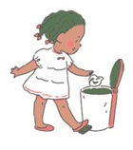

New Words:
Cavities: Cavities are holes that form in our teeth.
Scalp: The skin of our head is called the scalp.

Did You Know?
- If you cannot wash your hands with soap, then rub a few drops of sanitiser in your hands. It makes your hands clean and keeps all the germs away.
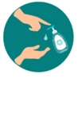
- Clean your dustbins once a week. Always put a plastic bag in your dustbin and then throw the litter in it.



